Comparison of Gradient Descent Optimization Algorithms
Project Summary, Key Points and Conclusion

1. Project Summary
This project studies and compares different gradient descent optimization algorithms used for minimizing a loss function. The objective is to understand how different update strategies affect the path taken during optimization, the speed of convergence, and the behavior of the loss during training.
The project is organized into three comparisons. The first compares Vanilla Gradient Descent, Stochastic Gradient Descent (SGD), and Mini-batch Gradient Descent. The second compares Vanilla Gradient Descent with Momentum-based Gradient Descent and Nesterov Accelerated Gradient (NAG). The third compares Vanilla Gradient Descent with the adaptive methods AdaGrad, RMSProp, and Adam.
For visualization, the optimization process is represented on a two-dimensional parameter space using the model parameters w and b. Contour plots represent different values of the loss function, while the optimization trajectory shows how an algorithm moves from its initial parameter values toward a lower-loss region. Separate plots are generated for each optimizer so that its individual behavior can be studied clearly.

2. Project Methodology
- Define a simple dataset and a sigmoid-based model with parameters w and b.
- Define the loss function and calculate its gradients with respect to w and b.
- Initialize all optimization algorithms from the same starting point.
- Apply the update rule corresponding to each optimization algorithm.
- Record the values of w and b after every update.
- Plot the optimization trajectory over the loss/error contour surface.
- Plot the loss against iterations to study convergence behavior.
- Compare the optimization behavior across the three algorithm groups.

3. Comparison 1: Vanilla GD, SGD and Mini-batch GD
The first experiment focuses on how the amount of training data used for each parameter update changes optimization behavior.
Vanilla / Batch Gradient Descent: Uses the complete training dataset to calculate the gradient before each parameter update. Its trajectory is generally smooth because the gradient is calculated from all available samples.
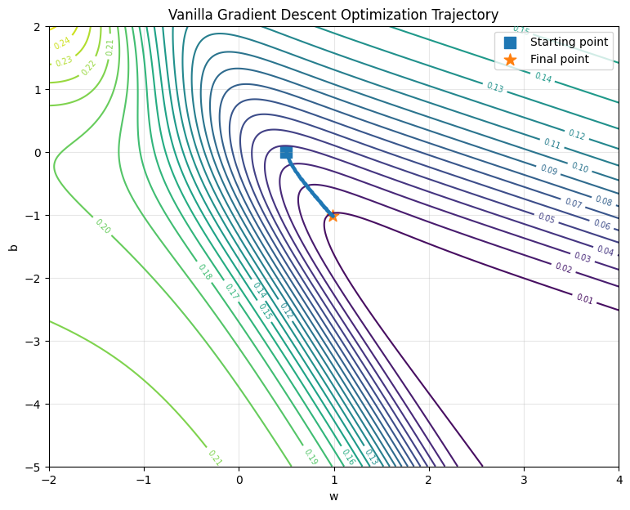
Stochastic Gradient Descent: Uses one training example for an update. Because each update is based on a single sample, the trajectory can be more irregular or noisy, although frequent updates can help the optimizer move quickly.
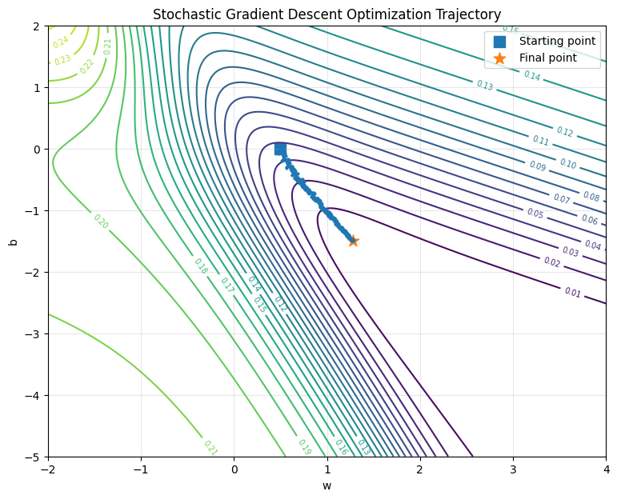
Mini-batch Gradient Descent: Uses a small subset of the training data for each update. It provides a compromise between the stable updates of batch GD and the frequent, potentially noisy updates of SGD.
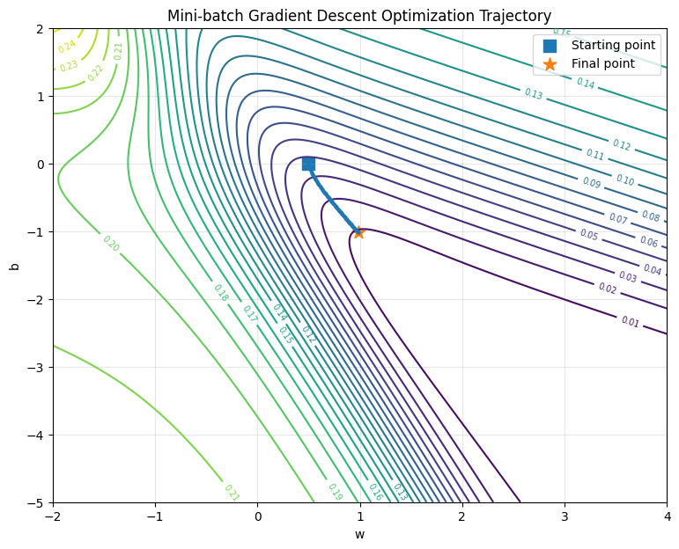

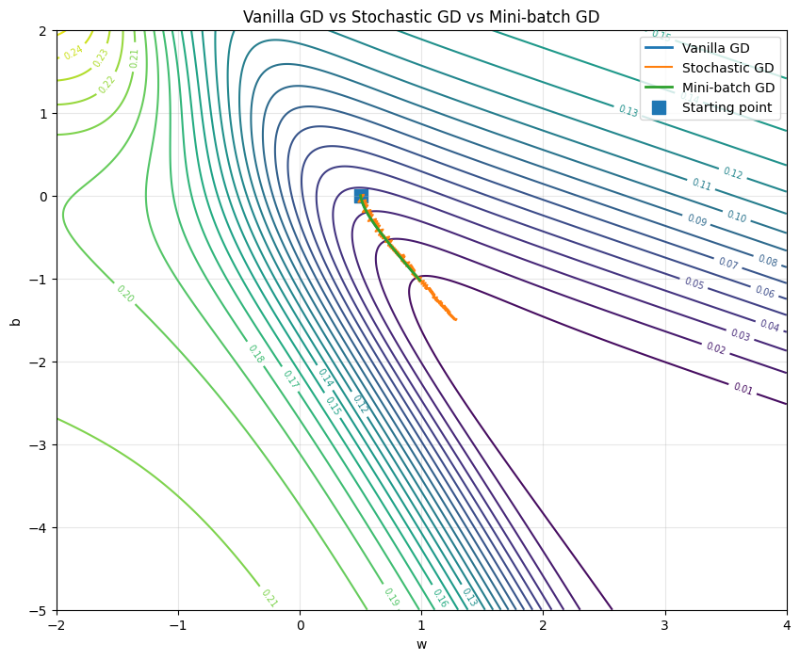
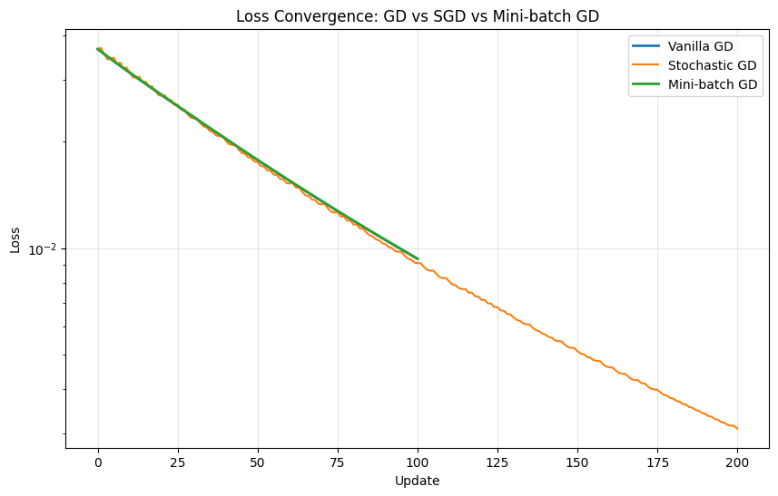

4. Comparison 2: Vanilla GD, Momentum and Nesterov
The second experiment examines methods that improve ordinary gradient descent by using information from previous updates or by estimating the gradient at a look-ahead position.
Vanilla Gradient Descent: Uses only the current gradient to determine the next update.

Momentum Gradient Descent: Maintains a velocity term based on previous updates. This allows the optimizer to build momentum in consistent directions and can reduce slow movement or oscillation in difficult regions of the loss surface.
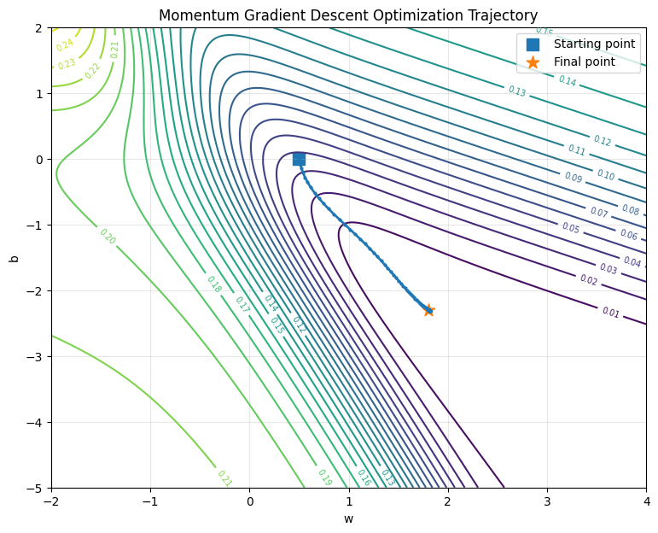
Nesterov Accelerated Gradient: Uses a look-ahead position when calculating the gradient. This gives the method information about the anticipated future position and can provide more responsive updates than ordinary momentum.
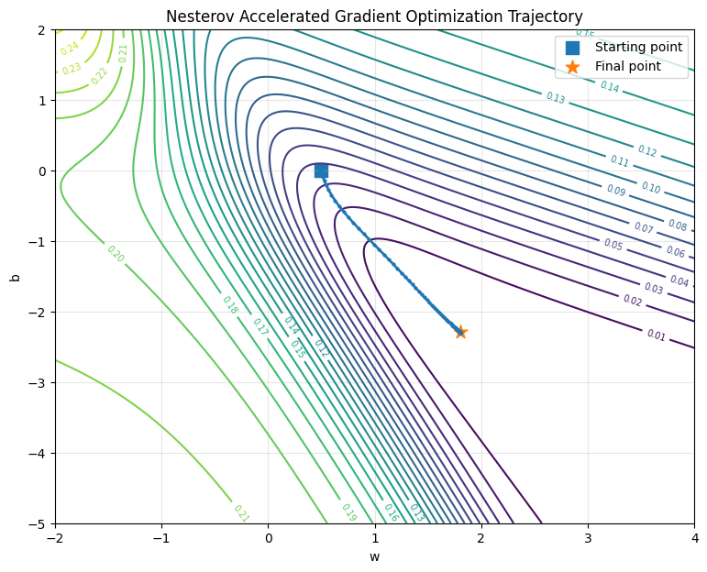

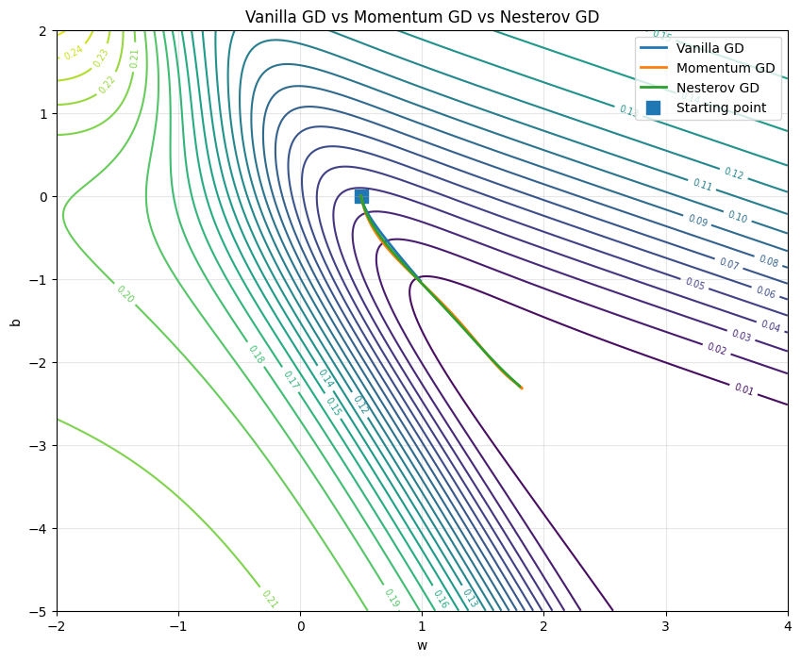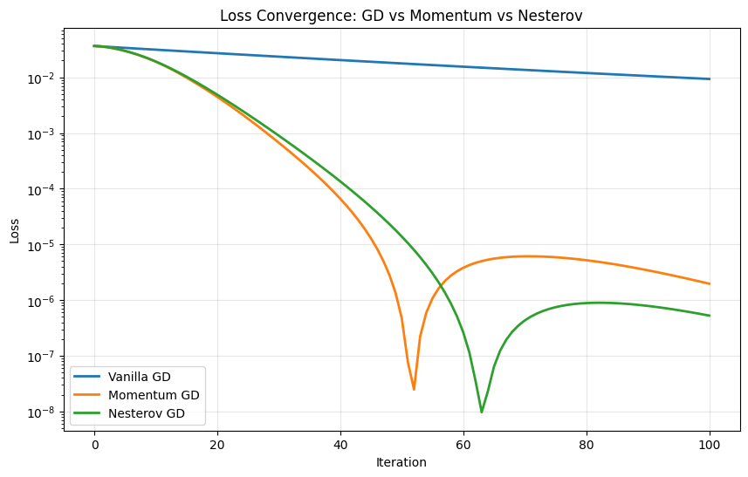

5. Comparison 3: Vanilla GD, AdaGrad, RMSProp and Adam
The third experiment studies adaptive learning-rate methods. These algorithms modify the effective learning rate according to gradient history rather than using exactly the same learning rate for every parameter.

AdaGrad: Accumulates squared gradients and uses this accumulated information to scale subsequent updates. This provides parameter-specific learning rates, although the accumulated value can continue growing and make later updates increasingly small.
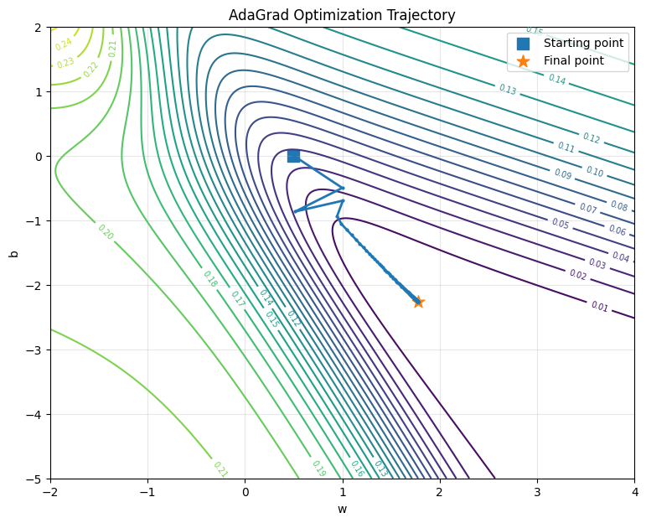
RMSProp: Uses an exponentially weighted average of squared gradients rather than an ever-growing cumulative sum. This helps prevent the learning rate from shrinking too aggressively.
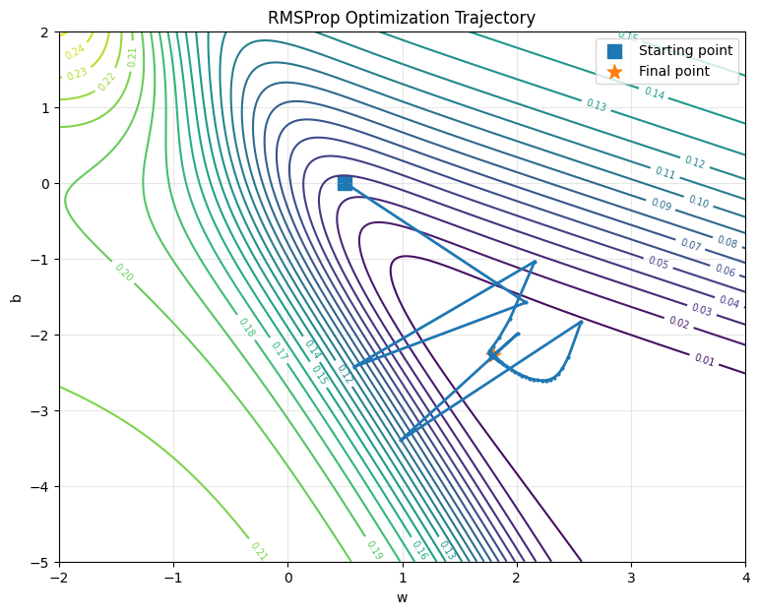
Adam: Combines first-moment information, which provides momentum-like behavior, with second-moment information for adaptive scaling. Bias correction is used for the moment estimates.
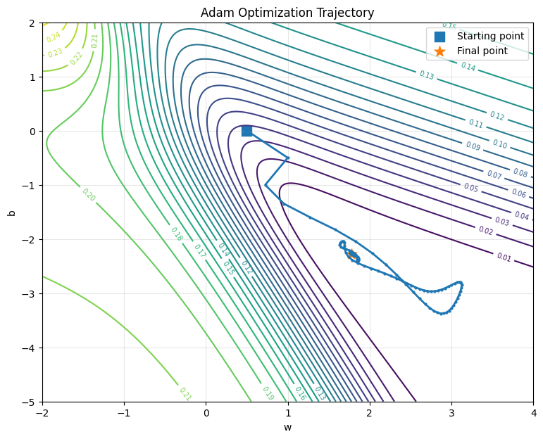

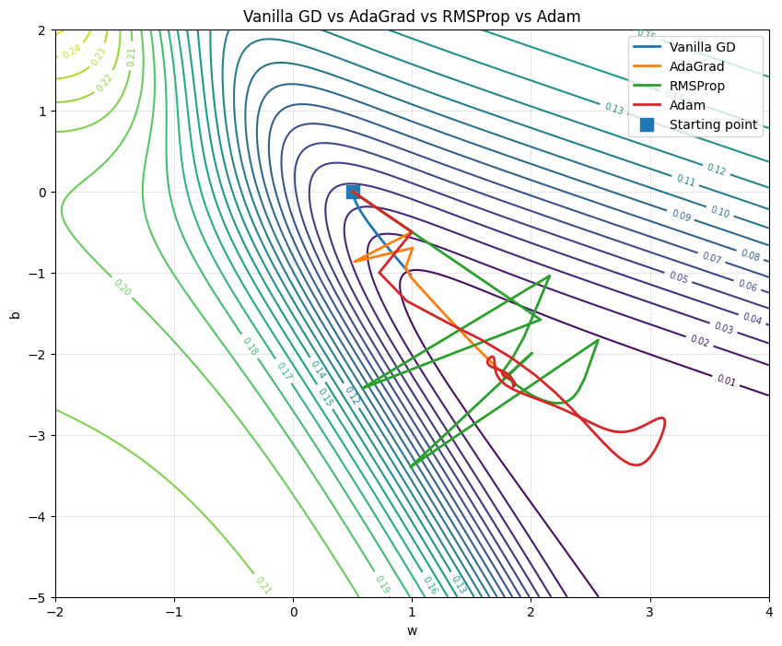
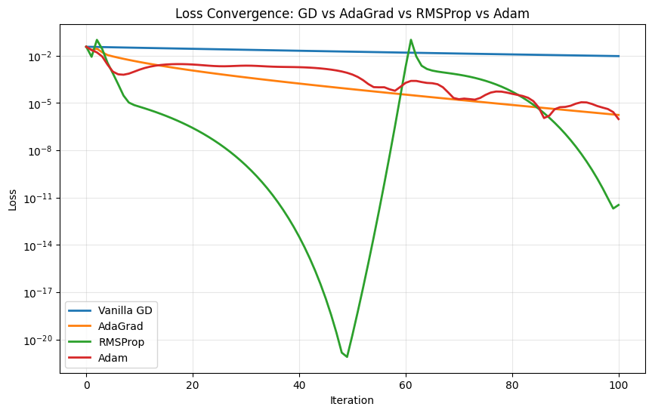

6. Key Points of the Project
- Gradient descent is an iterative optimization technique that updates model parameters in a direction intended to reduce the loss.
- The optimization trajectory depends strongly on how gradients are calculated and how previous gradient information is used.
- Batch GD produces updates using the complete dataset, while SGD uses one sample and Mini-batch GD uses a subset of samples.
- Momentum introduces a velocity term so previous updates influence the current movement.
- Nesterov Accelerated Gradient evaluates the gradient at a look-ahead position.
- AdaGrad adapts the learning rate using accumulated squared gradients.
- RMSProp uses an exponentially weighted average of squared gradients to control the adaptive learning rate.
- Adam combines first-moment and second-moment estimates and applies bias correction.
- Using the same initialization and loss surface makes visual comparison between optimizers more meaningful.
- Contour plots show where the loss is high or low, while the trajectory shows how an optimizer travels through parameter space.
- Loss-versus-iteration plots provide a complementary view of convergence behavior.
- Separate plots for each algorithm make individual optimization behavior easier to analyze than a single crowded comparison plot.

7. Main Observations
The experiments demonstrate that there is no single update rule that behaves identically under all conditions. The choice of optimizer changes the path through the loss surface and can influence convergence speed and stability.
Vanilla GD provides a useful baseline because its behavior is directly determined by the current gradient. SGD introduces greater update frequency and potential variability, while Mini-batch GD provides an intermediate strategy. Momentum and Nesterov modify the optimization dynamics by incorporating previous movement, whereas AdaGrad, RMSProp, and Adam modify the effective learning rate using gradient history.

8. Conclusion
This project provides a visual and conceptual comparison of major gradient descent optimization strategies. Starting from a common model, dataset, loss function, and initialization allows the differences between the optimizers to be observed through their parameter trajectories and loss curves.
The first comparison highlights the effect of batch size on gradient updates. The second demonstrates how momentum and look-ahead information alter the optimization path. The third shows how adaptive learning-rate methods use historical gradient information to control parameter updates.
Overall, the project shows that optimization algorithms differ not only in their mathematical update rules but also in the way they navigate the loss surface. Visualizing these trajectories provides an intuitive way to understand convergence, oscillation, gradient noise, adaptive learning rates, and the practical motivation behind commonly used optimizers.

9. Final Takeaway
The central takeaway is that gradient descent is a basic optimization framework, while variants such as SGD, Mini-batch GD, Momentum, Nesterov, AdaGrad, RMSProp, and Adam modify how gradient information is used to make optimization more efficient, stable, or adaptive. Comparing their trajectories and loss curves makes these differences easier to understand than studying the update equations alone.

